P R O J E C T S A N D P R O M P T S
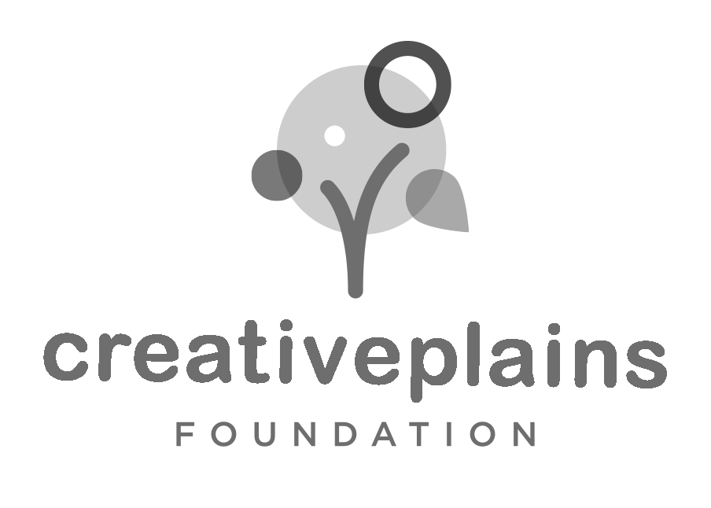
T O K E E P Y O U R
ART ACTIVITY
BOOK
B Y C R E A T I V E P L A I N S F O U N D A T I O N
C R E A T I V I T Y T H R I V I N G

ILLUSTRATE A BOOK COVER
Artists can create beautiful artwork for the walls of your home or for the cover of a book. Design your own book cover below, you can choose your own title or get inspired by one of these ideas. Maybe you could even write the story of what your book is about!
The Big Race Down Broadway
A
r
t
w
o
r
k

b
y

A
r
t
i
s
t
:
_
_
_
_
_
_
_
_
_
_
_
_
_
_
_
_
_
_
_
_
_
_
_
_
_
_
_
_
_
_

The Helpful Robot
School in Outer Space
Unicorn Party in the Forest

CREATE A PUZZLE
You can create your very own puzzle! Start by thinking about what you want to draw, maybe you have a photo to copy or have a favorite character you love to draw.

Use your imagination and color a design on the puzzle below, then cut the pieces out and see if you can put them back together!

BE A GRAPHIC DESIGNER
Every box and label that you see was created by an artist called a graphic designer. Graphic designers create a lot of different things like posters, business cards, and packaging for products like cereal, soda, and candy.

Use the templates below to create your own product packaging designs. Think about the name of your product and what colors you will use to make people want to buy it!

COLOR A MANDALA
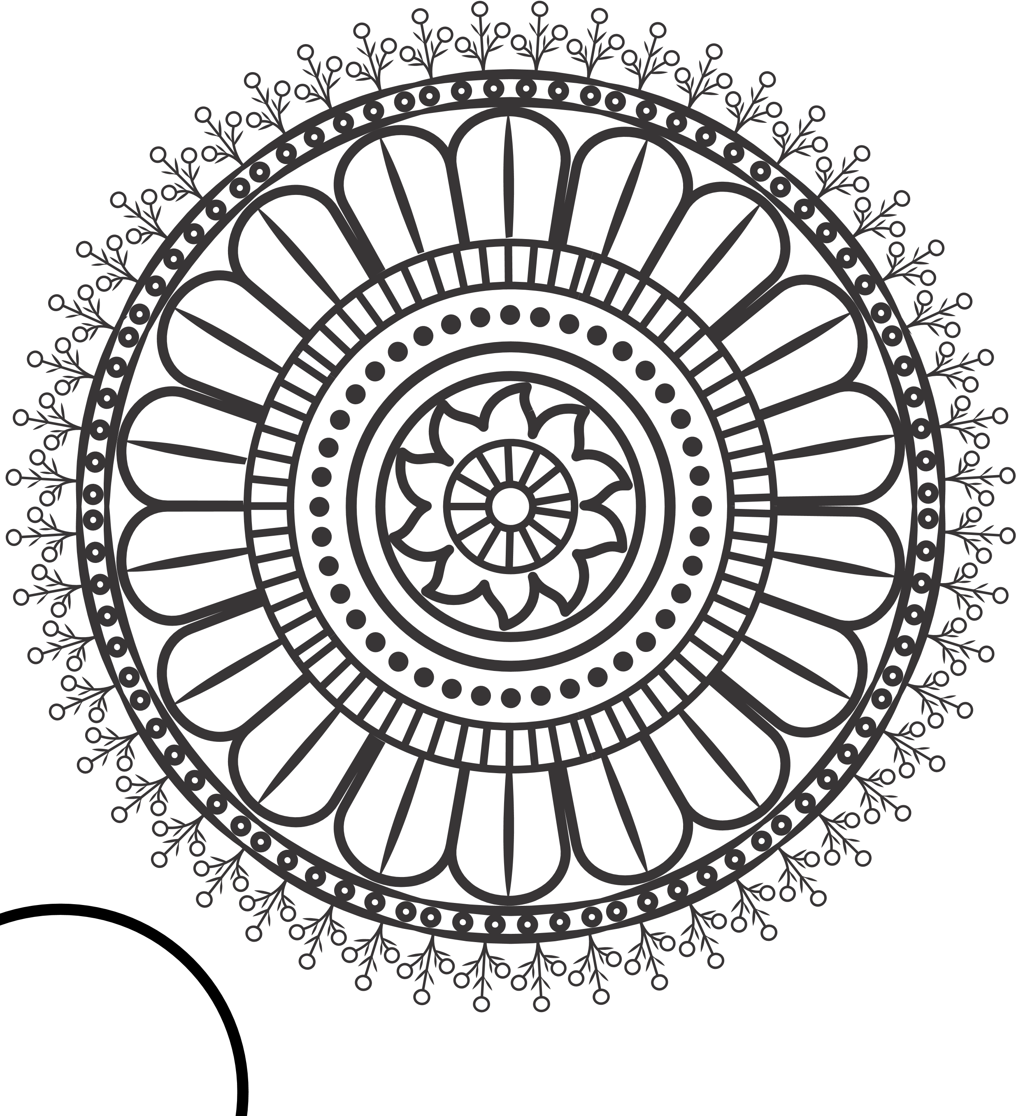
Use different colors to bring the mandala to life. Try a color scheme to create a beautiful design!

Red, Pink, Purple Yellow, Green, Blue Orange, Blue, Green

CREATE CHARACTERS
Transform the shapes below into unique characters. What is your character's name? What is their favorite food? Have fun creating stories for your characters.
E X A M P L E

WRITE A COMIC
Use the blank comic strip below to tell a story about a character you have either created or a character that you already know. Before you start, think about what will happen in each square and then draw! 1_____________________________________________
BAM!
2.____________________________________________
3.____________________________________________
4.____________________________________________
START
HERE!
THE END.
5.____________________________________________
6.____________________________________________

MAKE CIRCLE ART
Look around your house for circular objects you can trace... a can of vegetables, coins, plates, and bowls.

Set the objects on this paper and trace around them, Let the patterns overlap, then fill the spaces with color.
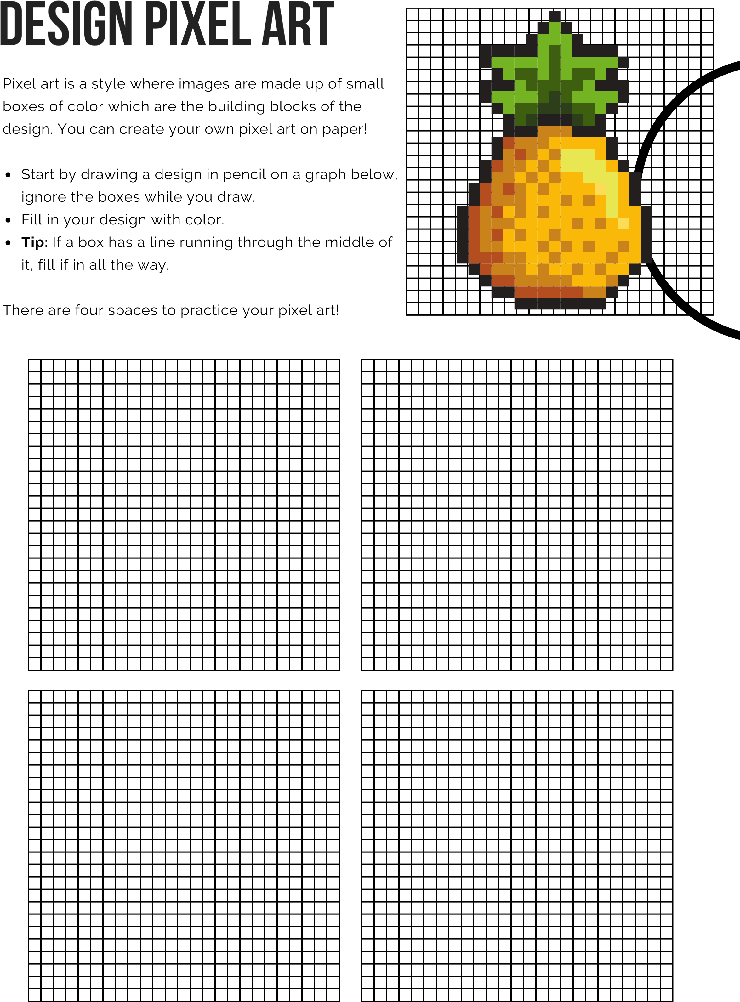

BE POSITIVE
Even if we don't always feel happy, using positive phrases can help us see what's good about ourselves and others.
i am
________

Use the word list below to circle your 3 favorite positive words add one word to the "I AM"statement in each box
and then draw what this looks like.
thankful focused loved | hopeful learning kind
Creative smart happy strong a good friend safe
i am
________
i am
________

